**Lab Practical #05:**

Study the concept of VLAN using packet tracer.

**Practical Assignment #05:**

1. **Implement the different network structures in VLAN and VLAN trunking. Also check connectivity between them using ping command or PDU utility.**

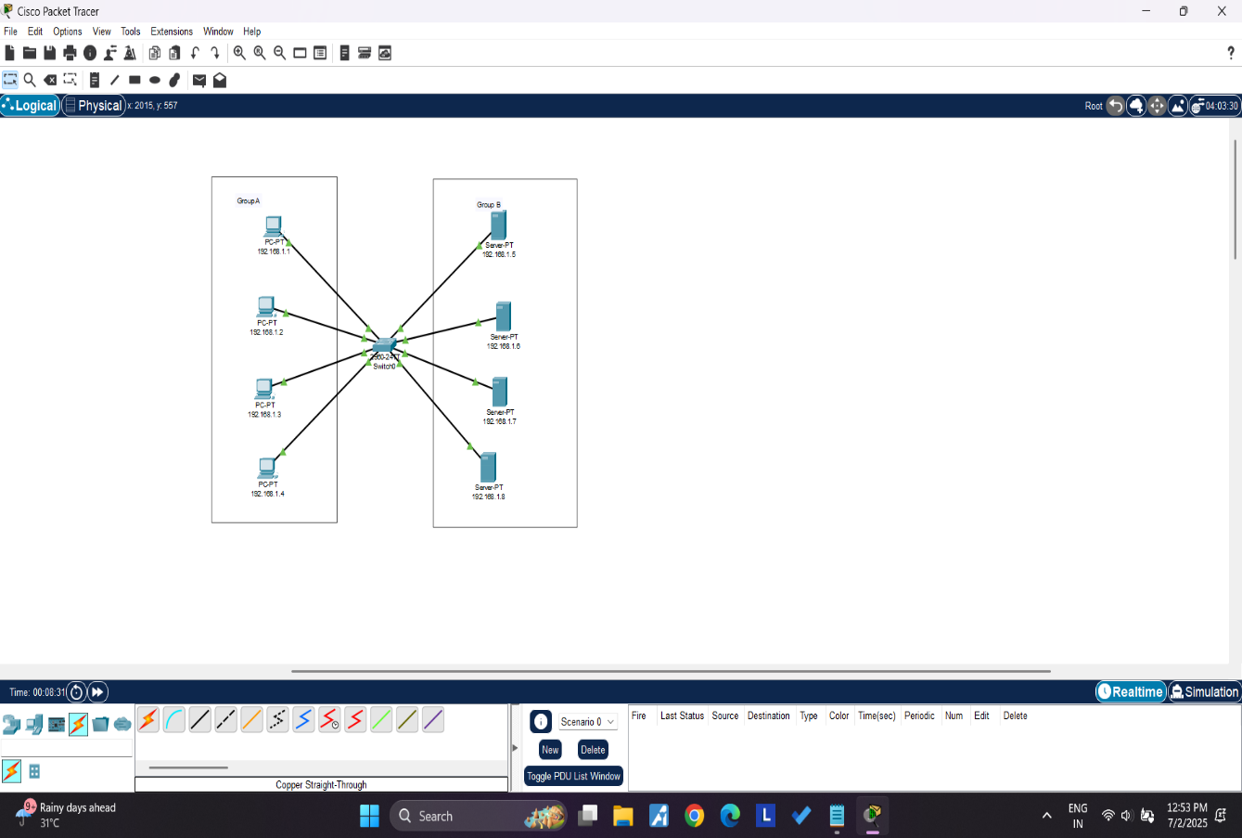

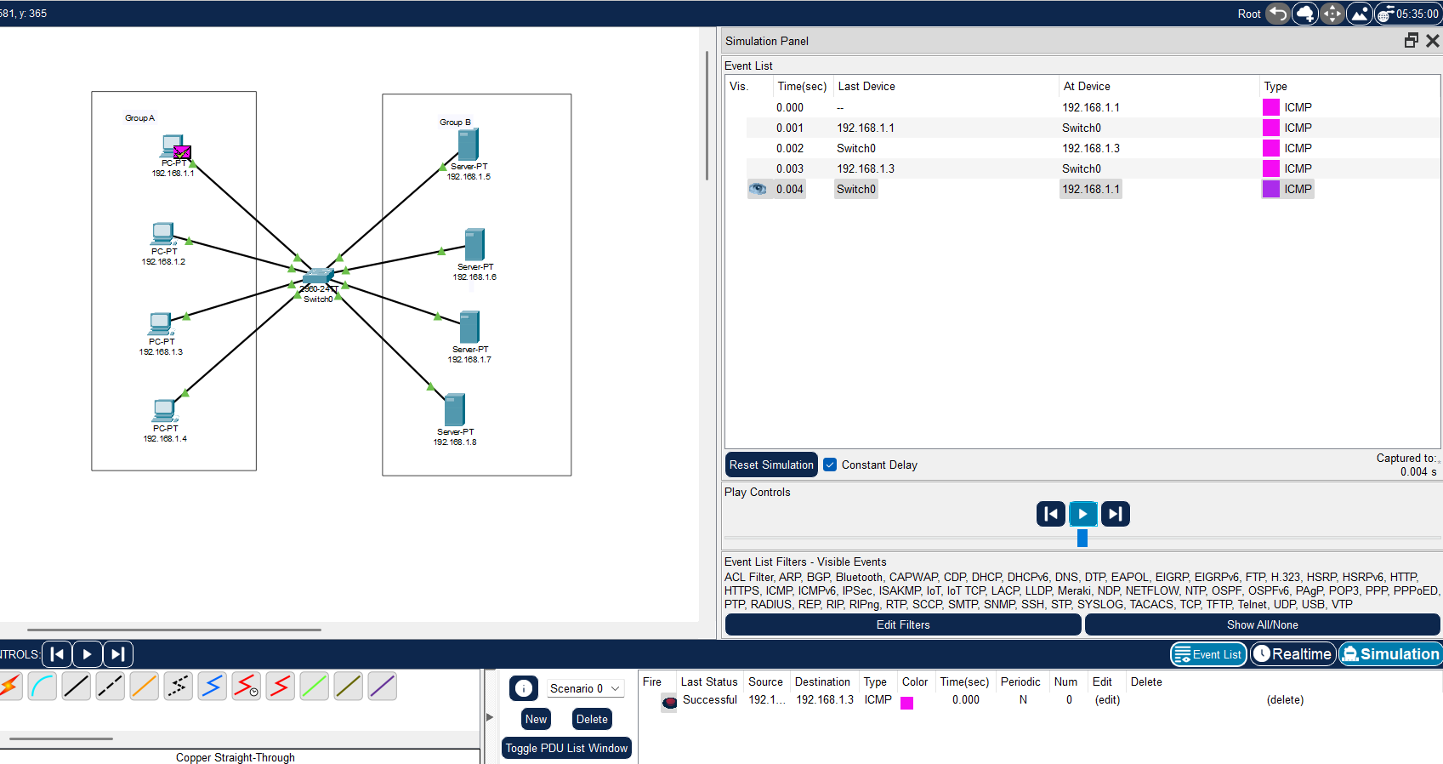

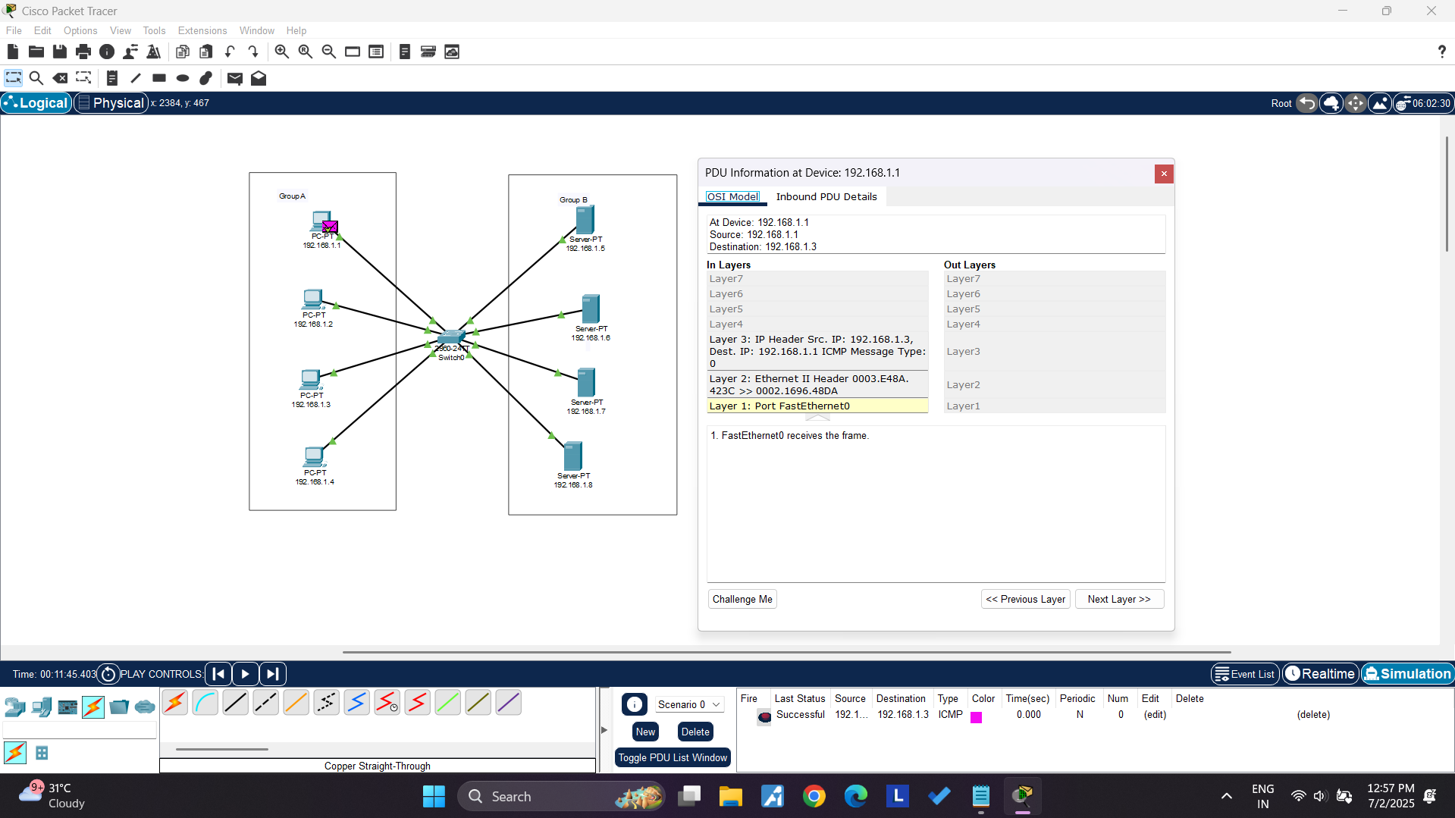

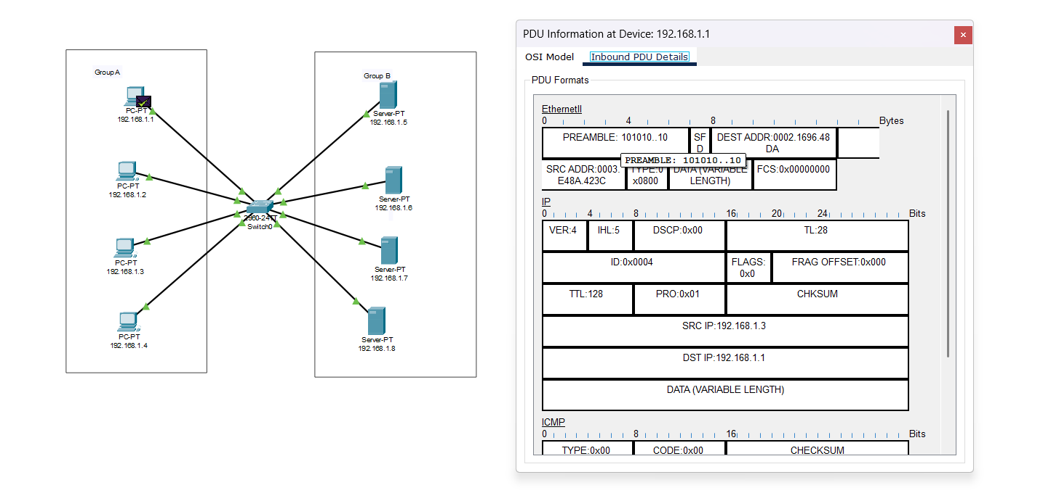

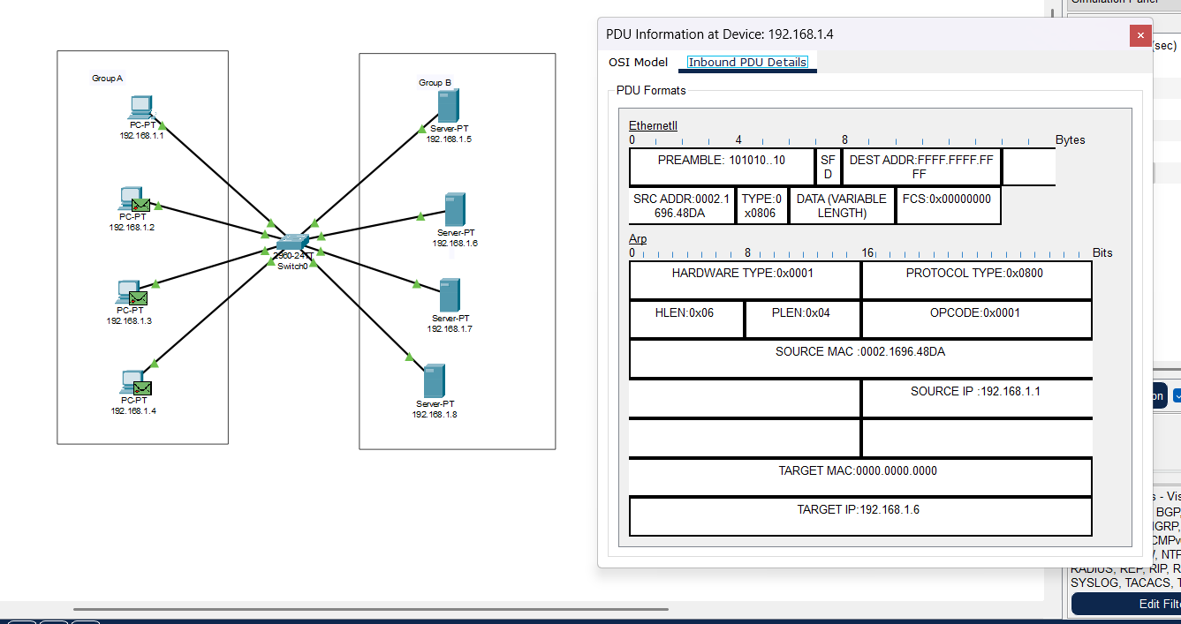

**Steps to Create VLANs in Packet Tracer**

**1. Open Packet Tracer and Create Your Topology**

* Drag a 2960 Switch into the workspace.
* Drag PCs into the workspace and connect them to the switch using Copper Straight-Through cables.

**2. Open the Switch’s Configuration Window**

* Click on the switch.
* Go to the Config tab.

**3. Create VLANs**

* In the VLAN Database section (left menu), click it.
* In the VLAN table:
  + Type VLAN ID (e.g., 10) and Name (e.g., Sales), then click Add.
  + Type VLAN ID (e.g., 20) and Name (e.g., HR), then click Add.

**4. Assign Ports to VLANs**

* In the left panel, click FastEthernet (for example, FastEthernet0/1).
* Under Port Mode, select Access.
* In VLAN, select the VLAN ID you want (e.g., 10).
* Repeat for each port, assigning them to the desired VLAN.

**5. Assign IP Addresses to PCs**

* Click each PC → Desktop → IP Configuration.
* Assign IP addresses within the same network for PCs in the same VLAN.

**6. Verify the VLAN Setup**

* PCs in the same VLAN should be able to ping each other.
* PCs in different VLANs will not communicate unless a router or Layer 3 switch is used.

**Instructions:**

1. Different VLANs configuration setup screenshot. (VLAN example given by lab faculty)
2. Write steps to create VLANs in packet tracer.
3. Mention IP address of each pc as label.
4. Ping command or PDU screenshot between two VLANs.